VELAMMAL BODHI CAMPUS
(A CBSE – IIT/NEET Integrated Sr.Sec.School)
CLASS : X PART TEST - I MARK:80
SUBJECT: SCIENCE Duration:3hrs
Name of the Student : Date:14.10.2023
SECTION –A
Select and write one most appropriate option out of the four options given for each of the questions 1 – 20 (20X1=20M)
1.A beam of light incident on a plane mirror forms a real image on reflection. The incident beam is:
(a) parallel (b) convergent (c) divergent (d) not certain
2. Magnification produced by a rear view mirror fitted in vehicles
(a)is less than one (b) is more than one (c) equal to one
(d) can be less than one or more than one depending upon the position of object in front of it
3. Assertion(A) : Danger signals are made of red colour.
Reason (R) : Velocity of red light in air is maximum, so signals are visible even in dark.
(a) Both assertion and reason are true and Reason is the correct explanation of Assertion
(b) Both assertion and reason are true and Reason is not the correct explanation of Assertion
(c) If Assertion is true , but Reason is false
(d) If Assertion is false , but Reason is true
CHE
4. Which of the statements about the reaction below are incorrect? 2PbO(s) + C(s) → 2Pb(s) + CO₂(g)
(a) Lead is getting reduced
(b) Carbon Dioxide is getting oxidised
(c) Carbon is getting oxidised
(d) Lead oxide is getting reduced
(i) (a) and (b)
(ii) (a) and (c)
(iii) (a), (b) and (c)
(iv) all the above
5 The image shows some chemical reactions.
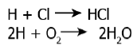
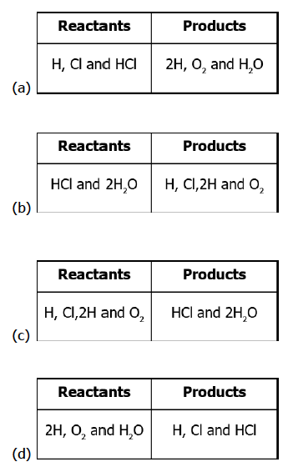
Which option identifies the reactants and products of the reactions?
6) Three beakers labelled as A, B and C each containing 25 ml of water were taken. A small amount of NaOH, anhydrous CuSO₄ and NaCl were added to the beakers A, B and C respectively. It was observed that there was an increase in the temperature of the solution contained in beakers A and B, whereas in case of beaker C, the temperature of the solution falls. Which one of the following statement(s) is (are) correct?
(i) In beakers A and B, exothermic process has occurred.
(ii) In beakers A and B, endothermic process has occuBftd.
(iii) In beaker C exothermic process has occurred.
(iv) In beaker C endothermic process has occurred.
(a) (i) only (b) (ii) only (c) (i) and (iv) (d) (iv), (ii) and (iii)3)
7 The condition produced by aerial oxidation of fats and oils in foods marked by unpleasant smell and taste is called:
(a) antioxidation (b) reduction (c) rancidity (d) corrosion
8)The apparatus given in the adjoining figure was set up to demonstrate electrical conductivity.
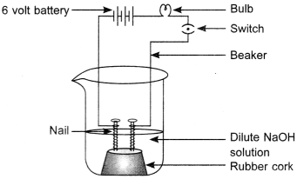
Which of the following statement(s) is (are) correct?
(i) Bulb will not glow because electrolyte is not acidic.
(ii) Bulb will glow because HCl is a strong acid and furnishes ions for conduction.
(iii) Bulb will not glow because circuit is incomplete.
(iv) Bulb will not glow because it depends upon the type of electrolytic solution.
(a) (i) and (iii) (b) (ii) and (iv) (c) (ii) only (d) (iv) only
9)Chemical formula of washing soda is
(a) Na₂C0₃ . 7H₂O (b) Na₂C0₃ . 5H₂O (c) Na₂C0₃ . 2H₂O (d) Na₂C0₃ . 10H₂O6)
10) Which one of the given is an organic acid?
A. Citric acid B. Hydrochloric acid C. Lactic acid D. Both (1) & (3)
11) Assertion (A) : The acid must always be added to water with constant stirring.
Reason (R) : Mixing of an acid with water decreases the concentration of H+ ions per unit volume.
A)) Both A and R are true and R is the correct explanation of A.
(b) Both A and R are true but R is not the correct explanation of A.
(c) A is true but R is false. (d) A is false but R is true.
12. Glycolysis process occurs in which part of the cell?
a) Cytoplasm b) Nucleus c) Mitochondria d) Chloroplast
13. The main function/s of kidney is/are
a) passive absorption b) ultrafiltration c) selective reabsorption d) both b and c
14. Small intestine receives secretions from
a) liver b) pancreas
c) both liver and pancreas d) salivary glands and gastric glands
15. Non biodegradable waste
a) can be degraded by microbes b) can be recycled
c) cannot be degraded by microbes d) both b and c
16. The chemical concentration must be highest in
a) Producers b) primary consumers
c) secondary consumers d) tertiary consumers
17. How much percentage of energy do the plants obtain from the sun?
a) 1% b) 5% c) 10% d) 100%
18. If the rate of translocation is slow then the rate of photosynthesis will
a) Increase b) Decrease c) be the same d) become double
19. Both respiration and photosynthesis are
a) similar processes b) Opposite processes
c) Endothermic processes d) Exothermic processes
20. Which of the following organ does not secrete a digestive enzyme in human being?
a) Buccal cavity b) Oesophagus c) Stomach d) Intestine

SECTION – B
Q. No. 21 to 26 are very short answer questions. (6 2 = 12)
21.If the image formed by a spherical mirror for all positions of the object placed in front of it is always erect and diminished, what type of mirror is it? Draw a labelled ray diagram to support your answer.
22.Draw a ray diagram to show the refraction of light through a glass prism. Mark on it (a) the incident ray, (b) the emergent ray and (c) the angle of deviation. Or
Write the function of each of the following parts of human eye:
i) Cornea (ii) Iris (iii) Crystalline lens
23). Identify the substances that are oxidised and that are reduced in the following equation.
i) 4Na(s) + O₂(g) → 2Na₂O(s) ii) CuO(s) + H₂(g) → Cu(s) + H₂O(l)
Or
Wht is indicator explain the difference between organic, inorganic indicator
24. We do not clean ponds or lakes, but an aquarium needs to be cleaned. Why?
25. How is the small intestine designed to absorb digested food?
26. What would be the consequences of a deficiency of haemoglobin in our bodies?
SECTION – C
Q.no. 27 to 33 are short answer questions (7 3 = 21)
27.An object of height 6 cm is placed perpendicular to the principal axis of a concave lens of focal length 5 cm. Use lens formula to determine the position, size and nature of the image if the distance of the object from the lens is 10 cm.
OR
A spherical mirror produces an image of magnification -1 on a screen placed at a distance of 50 cm from the mirror.
(a) Write the type of mirror.
(b) Find the distance of the image from the object.
(c) What is the focal length of the mirror?
(d) Draw the ray diagram to show the image formation in this case
28.The absolute refractive indices of glass and water are 4/3 and 3/2 respectively. If the speed of light in glass is 2 × 10⁸ m/s, calculate the speed of light in (i) vacuum, (ii) water.
29.What eye defect is myopia? Describe with a neat diagram how this defect of vision can be corrected by using a suitable lens.
30) Translate the following statements into chemical equations and balance them.
(a) Hydrogen gas combines with nitrogen to form ammonia.
(b) Hydrogen sulphide gas burns in the air to give water and sulphur dioxide.
(c) Barium chloride reacts with aluminium sulphate to give Aluminium chloride and a precipitate of barium sulphate.
(d) Potassium metal reacts with water to give potassium hydroxide and Hydrogen gas.
31) Write the use of Baking soda
32. Leaves of a healthy potted plant were coated with vaseline. Will this plant remain healthy for long? Give reasons for your answer.
33. a) What will happen if we kill all the organisms at one trophic level?
(Or)
b) What limits trophic levels in an ecosystem?
SECTION - D (1 5 = 5)
Q.no. 34 to 36 are long answer questions (3 5 = 15m)
34.1.Draw a diagram and apply conventions for calculating focal length and nature of a spherical mirror which forms a times magnified virtual image of an object placed 18 cm, in front of it. Or
34.2 a) A 5 cm tall object is placed perpendicular to the principal axis of a convex lens of focal length 20 cm. The distance of the object from the lens is 30 cm. Find the position, nature and size of the image formed.
(b) Draw a labelled ray diagram showing object distance, image distance and focal length in the above case.
35) i.writeany three chemical properties of acids
ii) what is plaster of Paris
Or
Explain the following terms with one example each.
(a) Corrosion
(b) Rancidity
c) Why do we apply paint on iron articles?
36. a) Draw a diagram depicting Human Alimentary Canal and label on it Gall Bladder, Liver and Pancreas.
(i) State the roles of Liver and Pancreas.
(ii) Name the organ which performs the following functions in humans:
(iii) Absorption of digested food.
​(iv) Absorption of water.
(Or)
b) In the following food chain, vertical arrows indicate the energy lost to the environment and horizontal arrows indicate energy transferred to the next trophic level.
In the following food chain, vertical arrows indicate the energy lost to the environment and horizontal arrows indicate energy transferred to the next trophic level
Which one of the three vertical arrows (A, C, and E) and which one of the two horizontal arrows (B and D) will represent more energy transfer?
Give a reason for your answer.
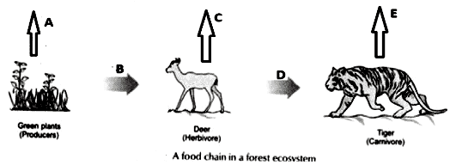
SECTION - E
Q.no. 37 to 39 are case - based/data -based questions with 2 to 3 short sub - parts. Internal choice is provided in one of these sub-parts
37. Read the following passage and answer the questions: 4X1=4M
There are various natural phenomenon associated with light. Refraction of light is the phenomenon in which when light travels from one transparent medium to another transparent medium it changes its direction. The change in direction of light is due to the change in velocity of light in different media. And hence the path of the light also changes in different media. In case of refraction of light through rectangular glass slab we must observe that the incident ray and the emergent ray are parallel to each other. We can see the pencil immersed in water as bent at the water air interface only because of the refraction of light. Again second phenomenon is dispersion of light in which white light when passed through the prism it splits into seven coloured spectrum. And these seven colours are VIBGYOR. We can see here the angle of deviation is different for different colour because different wavelengths of different colour. Also, Newton observed that when second prism is placed inverted to first prism the white light incident on the first prism will come out as white light only when emerges out from second prism. The phenomenon of formation of rainbow is also because of the dispersion of light. In that case the tiny water droplets acts as prism.
But most importantly, the refraction of light occurs only because of the change in refractive index of medium. The twinkling of stars is due to the atmospheric refraction of light.
Questions:
1) Rainbow formation takes place because of which phenomenon related to light?
2) For which colour the velocity is more in case of dispersion?
3) Why atmospheric refraction occurs?
4) For which colour the angle of deviation is more in case of dispersion?
38) Read the following passage and answer the questions: 4X1=4M
chemical reaction is a representation of chemical change in terms of symbols and formulae of reactants and products. There are various types of chemical reactions like combination, decomposition, displacement, double displacement, oxidation and reduction reactions. Reactions in which heat is released along with the formation of products are called exothermic chemical reactions. All combustion reactions are exothermic reactions.
i)The massive force that pushes the rocket forward through space is generated due to the
(a) combination reaction (b) decomposition reaction
(c) displacement reaction (d) double displacement reaction
(ii) A white salt on heating decomposes to give brown fumes and yellow residue is left behind. The yellow residue left is of
(a) lead nitrate (b) nitrogen oxide (c) lead oxide (d) oxygen gas
(iii) Which of the following reactions represents a combination reaction?
a).CaO (s) + H2O (l) → Ca (OH)2 b) CaCO3 (s) →CaO (s) + CO2(g)
c) Zn(s) + CuSO4 (aq) → ZnSO4 (aq) + Cu(s) d) 2FeSO4(s) → Fe2O3 (s) +SO2(g) + SO3(g)
(iv) Complete the following statements by choosing correct type of reaction for X and Y.
Statement 1: The heating of lead nitrate is an example of ‘X’ reaction.
Statement 2: The burning of magnesium is an example of ‘Y’ reaction.
(a)X-Combination,Y-Decomposition (b)X-Decomposition,Y-Combination
c)X-Combination,Y-Displacement (d) X- Displacement, Y-Decomposition
39. Read the following passage and answer the questions: 4X1=4M
i) The given figure best represents:
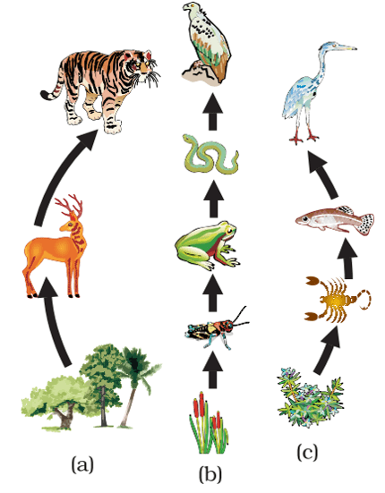
a. Food chain in forest, pond, and grassland b. Food chain in grassland, pond, and forest
c. Food chain in forest, grassland, and pond d. Food chain in pond, forest, and grassland
ii) Why do all food chains start with plants?
a. Because plants are easily grown b. Because plants are nutritious
c. Because plants can produce their own energy d. Because plants do not require energy
iii) In the food web, what two organisms are competing for food?
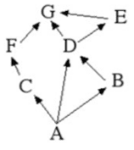
a. A and B b. D and F c. A and C d. B and D
iv) The decomposers are not included in the food chain. The correct reason for the same is because decomposers:
a. Act at every trophic level of the food chain
b. Do not break down organic compounds
c. Convert organic material to inorganic forms
d. Release enzymes outside their body to convert organic material to inorganic forms
v) Matter and energy are two fundamental inputs of an ecosystem. Movement of
a. Energy is bidirectional and the matter is repeatedly circulating
b. Energy is repeatedly circulation and the matter is unidirectional
c. Energy is unidirectional and the matter is repeatedly circulating
d. Energy is multidirectional and the matter is bidirectional

